

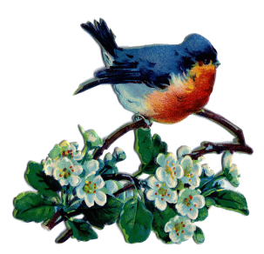***December Good News 2023***

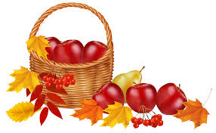**Our ministry vision for the Virginia Annual Conference is *“to be disciples of Jesus Christ who are lifelong learners, who influence others to serve.”***

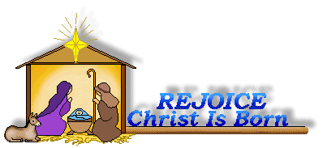

**From Pastor Adam**

“Who Was Saint Nicholas?”

*'Twas the night before Christmas, when all through the house*

*Not a creature was stirring, not even a mouse;*

*The stockings were hung by the chimney with care,*

*In hopes that St. Nicholas soon would be there.*

Sometimes we are not quite sure how to reconcile the popular notions of Santa Claus with the Christian tradition. Still, Santa serves a number of practical functions. The practice of going to the mall and sitting on Santa’s lap is a great way for parents to “overhear” a child’s wants and wishes for the Christmas season. It’s also a great way to obtain a cute photograph of our wee ones (provided that the encounter with Santa doesn’t leave them in tears – sitting on the lap of a mysterious bearded stranger can be unsettling for some children). When we want to give a Christmas gift anonymously, we can simply mark the card “from Santa.” There is of course the concern that recognition of Santa might draw attention away from the primary focus enjoyed by Baby Jesus. The fact that in time someone must step up and explain to children that Santa is not “real” in the same way that Jesus is real is something that can feel ethically awkward (we perpetuate a myth through early childhood only to smash it in early adolescence). The seemingly miraculous nature of Santa (visiting every household on the globe in a single night) may seem a distraction from the miraculous in the Bible and Christian tradition. Then when it becomes apparent that Santa (as we generally think of him) is not “real,” does that also raise questions about the reality of other spiritual beings (God, Jesus, angels)? I think there may be a way around this controversy, and that is to remember that the notion of Santa Claus is based upon a Saint Nicholas of Myra, a Christian saint and bishop in the early church. Tradition holds that Nicholas lived between 270 and 343 A.D. He was born in what is modern-day Turkey and we as known for his abiding sense of generosity. In one important memory of him, he would drop bags of gold coins through the window at the home of a poor man with three daughters. Over the course of three nights, Nicholas secretly left the gold coins so that the father could pay the marriage dowry for each daughter. This assured that each daughter would have measure of safety and security in life, and according to tradition, this prevented them from being sold into slavery. After the the first two bags of coins appeared, the father, much like the person in the poem *The Night Before Christmas*, waited to spot this kindly and generous stranger.

*According to Michael the Archimandrite's account, after the second daughter was married, the father stayed awake for at least two nights and caught Saint Nicholas in the same act of charity toward the third daughter. The father fell on his knees, thanking him, and Nicholas ordered him not to tell anyone about the gifts. The scene of Nicholas's secret gift-giving is one of the most popular scenes in Christian devotional art, appearing*

*in icons and frescoes from across Europe.* (“Saint Nicholas,” Wikipedia)

The Christmas tradition of hanging stockings by the fireplace goes back to this story about the generosity of this follower of Jesus who put the concerns of others before himself. It is also understood that upon the death of his parents, Nicholas distributed his entire would-be inheritance to the poor. Nicholas was present at the Council of Nicea in 325 A.D., and at this gathering of bishops, he helped create that language that would become the Nicene Creed which can be found in our United Methodist Hymnal (880). The creed reminds us that Jesus is the Divine Son and that we believe in the Holy Trinity. In the Roman Catholic tradition, Nicholas is the patron saint of sailors, merchants, archers, repentant thieves, children, brewers, pawnbrokers, unmarried people, and students. There are many stories surrounding the life of Nicholas, but they all point back to a founding principle – Nicholas experienced the love of Christ and that love radiated through his life and into the world. When we see Saint Nicholas in Santa Claus, we acknowledge that Christ shows up in human culture in wonderful and surprising ways.

God bless you my friends….and Merry Christmas, Adam

Circle News****

The Wesleyan Group …will meet on Monday, December 11, 2023, 6:30 p.m., at Charley’s. We will not meet in January or February.

The Merry Marthas Circle will not meet in December. We will meet Thursday, January 18 at 10:00 in the OMU room at church. We will have our "Pledge to Missions" for 2024, followed by lunch at Charley's.

~*Judy Robertson*

*Mission Memo*

For November the food cart contained 132lbs of food for Park View Mission. They were thankful for our donations and they will help to provide food for their clients for Thanksgiving. We will continue to collect the same items for December ~ Canned vegetables, stuffing mix, instant potatoes, rice, cranberry sauce, and any other side dish to make a great holiday meal. Thank you to all who faithfully support this outreach mission.

~*Linda Jessen & Mission Committee*

**Food Cart..December**

Canned vegetables, stuffing mix, instant potatoes, rice, cranberry sauce, and any other side dish to make a great holiday meal.

*No* ***“baked goods”*** *!* *Place donations in the grocery cart, located in the Commons*.



**The choir** will be singing on Sunday, December 10 & 24, and will be rehearsing

at 10 AM. We will sing familiar hymns so please come join us!

*~Heather Wilson*, Director of Music

***Park View Closet ~ Winter Clothing***

Needed: Park View is now accepting winter clothing. Bring items to church and Linda Jessen will take to the mission. Bring items to church, **Monday—Thursday**, 9:30 a.m. to 3:00 p.m.

**Angel Tree**

We are sponsoring an Angel Tree again this year for the children of clients with Humankind’s Ways

to Work program. You may take one (or more) and shop for him or her, or you may make a monetary donation and the Humankind staff will do the shopping. There is a sign-up sheet by the Angel Tree. Please sign whether taking an angel or writing a check. All checks should be made out to Chestnut Hill UMC, with “Angel Tree “ on the memo line. Gifts should be wrapped and the child’s name on each gift. **Gifts and checks should be turned in by Sunday, December 10th.**

Pat Short's **"Mitten Tree Trunk"** will again be available for donations of mittens, gloves, hats, scarves, and socks. These will be distributed as needed by HumanKind, so they can be purchased after Christmas when on sale if you like.

We have set a goal of $7,500.00 for our Christmas offering. 45% will go toward congregational fellowship fund; 45% will go toward padded chairs for fellowship hall; and 10% will go toward Park View Missions.



*Erin Long* is providing an Advent Study that is continuing on Wednesdays, December 6 & 13 at 6:00 p.m., here at Chestnut Hill. If you would like to attend let Erin or the church office know.

Christmas Eve Candlelighting Service

 Sunday, December 24, 2023 @ 4:30 p.m.

*We will have refreshments in the social hall after the evening Christmas Eve service. Please bring a plate of your favorite cookies, brownies, or other finger foods. There will be punch and water to drink. Please invite friends and family members to come. We always have plenty to share! Contact Judy Robertson if you can help put out the goodies and serve the punch.*

**District Advent Brunch**

The District Advent Brunch for all women of the church (whether you belong to a circle or not) will be Saturday, Dec. 2, at 9:00 a.m. at Rustburg United Methodist Church. Cost is $5.00. Breakfast will be prepared by the women of the church. There will be a musical program by Kelly Henshaw. An offering will be taken for Fairview UMC Food Pantry. They will also collect items for Park View Community Mission. Let Judy Robertson know ASAP if you want to go and I will give you a list of items for PVCM. Frances Unruh and I are planning to go, and I will be glad to take 2 others.  Cell phone #434-851-2901.



**NEWSLETTER:** We will be combining the newsletter for January/February 2024. Deadline for articles will be Monday, December 18th.

***Estimate of Giving for 2024***

It is that time of year when we are all asked to take a prayerful look at our giving and to make a financial commitment for CHUMC ministries. Please fill out the **“tear off”** pledge (provided in the December issue) or pick up a card (provided in the Commons) and send to CHUMC or put it in the weekly offering plate during December so that we have your pledge by the end of December. We plan to have a luncheon after church in February to celebrate our statement of faith to support the ministries of CHUMC. More information provided later.

December 2023

|  |  |  |  |  |  |  |
| --- | --- | --- | --- | --- | --- | --- |
| *Sunday* | *Monday* | *Tuesday* | *Wednesday* | *Thursday* | *Friday* | *Saturday* |
|  | | | | | **1**  10:00am Homeschool  3:30pm Homeschool/Preteen Christmas Parties | **2**  9:00 am  Dist. Advent Brunch, Rustburg UMC |
| **3** *First Sunday in Advent*  9:30am Sunday School  10:30am Worship | **4** | **5** | **6**  6:00pm Advent Study | **7** | **8**  10:00am Homeschool | **9** |
| **10** *Second Sunday in Advent*  9:30am Sunday School  10:00am Choir  10:30am Worship | **11**  6:30 pm Wesleyan Group @ Charleys | **12** | **13**  6:00pm Advent Study | **14** | **15**  10:00am Homeschool | **16** |
| **17** *Third Sunday in Advent*  9:30am Sunday School  10:30am Worship | **18** | **19** | **20** | **21** | **22** | **23** |
| **24** *Fourth Sunday in Advent*  9:30am Sunday School  10:00am Choir  10:30am Worship  4:30pm Christmas Eve Service/Reception | **25** *Christmas Day*  ***Church Office Closed*** | **26**  ***Church Office Closed*** | **27** | **28** | **29** | **30** |
| **31** *First Sunday after Christmas*  9:30am Sunday School  10:30am Worship |  | | | | | |



1 Pat Short

2 Nancy Lee

Emily V.

Fernandez

3 Michael McGlothlin

6 Kirsten Bell

Tim Crist

Dennis Tolley

7 Kenny Busic

Cheryl Powell

9 Owen Stinnette

Jeremey

VandeBogart

11 Landen Glass

12 Camden Mason

14 Wade Ware

16 Burton Brooks

Terry Palazzi

Anne-Elaine Tiller

17 Suzanne

Marshall

Blake Phillips

18 Sharon

Rickmon

19 Connie Yost

20 Erin Ecklund

21 Steven Kinzer

22 C.O. Bell

25 Frankie

Hardwick

28 Jacqueline Busic

Cheryl Thomas

29 Wes Robbins

Ricky Smith

31 Robert Baunach

**2022**

**March 2022**

**Our Church Financial Picture**

Through the end of October 2023

General Operating Funds:

Needed to meet our 2023 Budget $ 196,989

Needed to meet our budget to date $ 164,157

Actual receipts to date $ 132,726

Shortage to meet budget to date $ 31,421

Actual expenditures to date $ 133,571

Shortage to meet expenses to date $- 845

Joy In Missions Funds

Our Giving Goal for 2023 $ 9,600

Needed to meet our goal to date $ 8,000

Actual receipts to date $ 9,470

Special Offerings* (not budgeted):

Received to date $ 7,620

Dispersed to date $ 6,390

*Christmas, Easter, Annual Conference,

World Communion, etc.

**2023 Joy In Mission Donations**

To date, the following amounts have

been paid to the missions indicated.

Budget Spent

1. Missionary Covenant Relationship

$1,000 $ 750

2. Park View Mission, Food for Families

$3,000 $2,640

3. Society of St. Andrew $1,000 $ 750

4. Adult Care Center $ 500 $ 0

5. Blue Ridge Area Food Bank $1,000 $ 750

6. Daily Bread $ 500 $ 375

7. Free Clinic $ 500 $ 0

8. Good Neighbor $ 500 $ 0

9. Habitat for Humanity $ 500 $ 375

10. UMCOR-Non-Administrative $ 500 $ 0

11. Undesignated $ 600 $ 60

12. UMCOR-Hawaii $ 1,000

13. Meals on Wheels (Souper Bowl) $ 1,015

Thank you for your generosity.

**Those Who Serve ~ December**

**GREETERS:**

December 3 ~ Ann Robbins

December 10 ~ Maggie Musgrove

December 17 ~ Jane White

December 24 ~ Dan Robertson

December 31 ~ Betty Taylor

**GOOD NEWS** is

published monthly for members and

friends of Chestnut Hill United

Methodist Church. Send articles to

the church office by the 15th of the

month. (Subject to change).

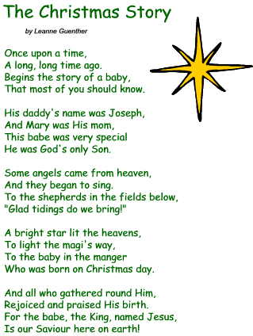



January 2022

**2022**





**April 2022**

**April 2022**

**March 2022**

*Chestnut Hill United*

*Methodist Church*

4660 Fort Avenue, Lynchburg, VA 24502

Phone Number: 434-239-8423: FAX: 434-239-7209

E-mail: [chestnuthillumc@comcast.net](mailto:chestnuthillumc@comcast.net)

On the web: www.chestnuthillumc.net

Church Office Hours

**Monday-Thursday~**9:00 am—3:30 pm

**Friday~**9:00 am-1:00 pm

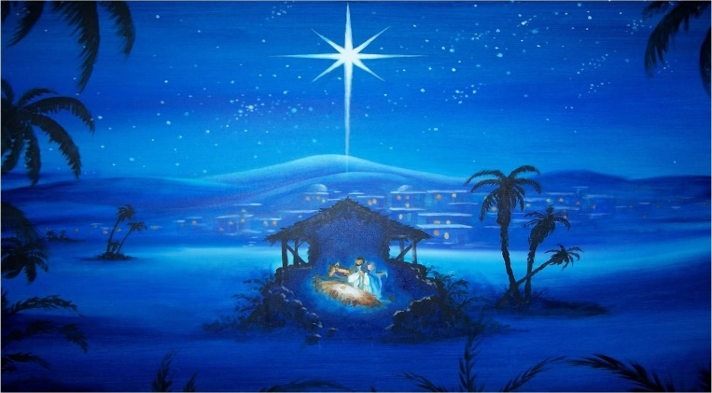

***DIRECTORY OF***

***CHESTNUT HILL UNITED METHODIST CHURCH***

|  |  |  |
| --- | --- | --- |
|  | Sue Haupert-Johnson | Richmond Area Resident Bishop |
|  | Denise Bates | Mountain View District Superintendent |
|  | Adam White | Minister |
|  | Erin Long | Associate Minister |
|  | Monica Campbell | Administrative Assistant |
|  | Heather Wilson | Director of Music Ministry |
|  | Judy Martin | Bookkeeper |
|  | Judy Robertson | Lay Leader |
|  | Elizabeth Nichols | Missionary in Henry County |